Download-Upload Assignments

D2L provides an option for a teacher to download all assignments from the Assignment Dropbox, leave feedback within the files, then upload them back to the appropriate dropbox folder so they appear as attachments to each user’s submission evaluation.
Logon to Desire2Learn (NS Online). To download all or selected assignments, go to the Assignment Dropbox and click on the title of the assignment. Select individual students or select all students. Click the Download link.
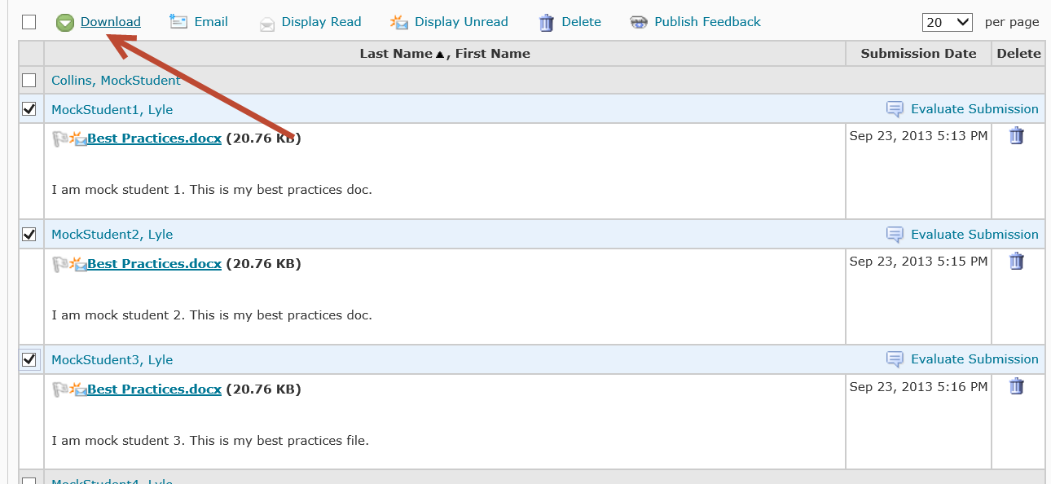
Click on the title of the zip file to download it, then click on View downloads.
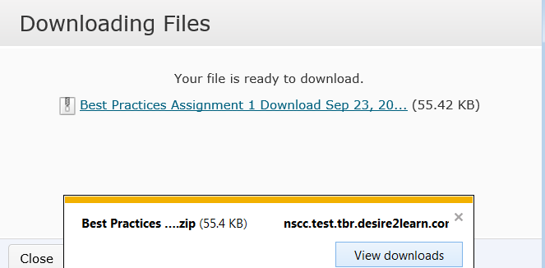

Click on Save.
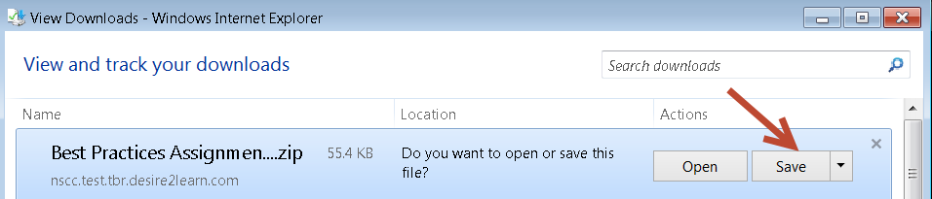
Save the file at a location where it can be easily located. This file is saved to the Downloads folder. Click on Open.
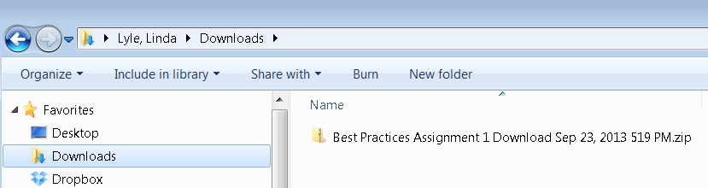
Click on “Extract all files.”
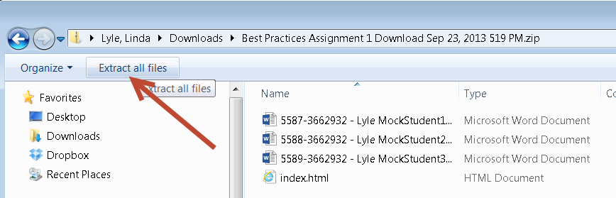
By default, a folder with the same name and path as the zip file will be created and the files will be extracted to that folder.
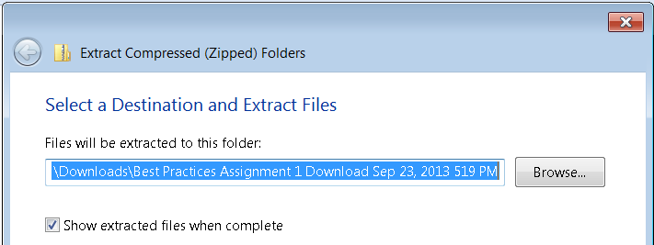

After the files are extracted, click on each one file to open it. In this illustration, the files open in Word. Edit the file using the comment and/or markup features in Word.
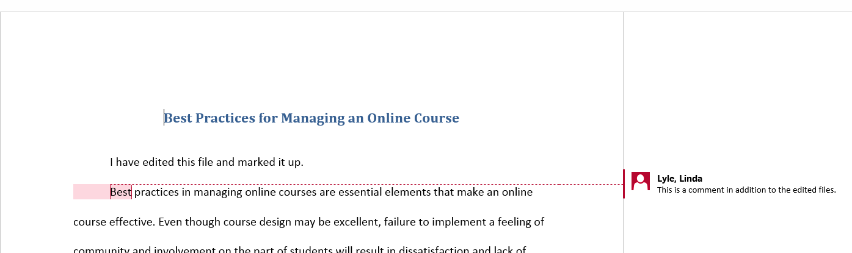
Return to Desire2Learn (NS Online) and go to the Assignment Dropbox. Click on the title of the assignment. The Folder Submission page displays.
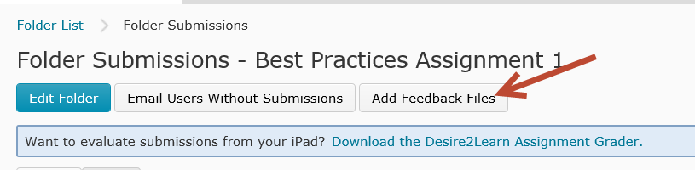
Click on Add Feedback Files. Upload the individual files by dragging them to the drag-and-drop specialized area. In the illustration below, the individual files have been selected and dragged to the drag-and-drop area. Click on Add.
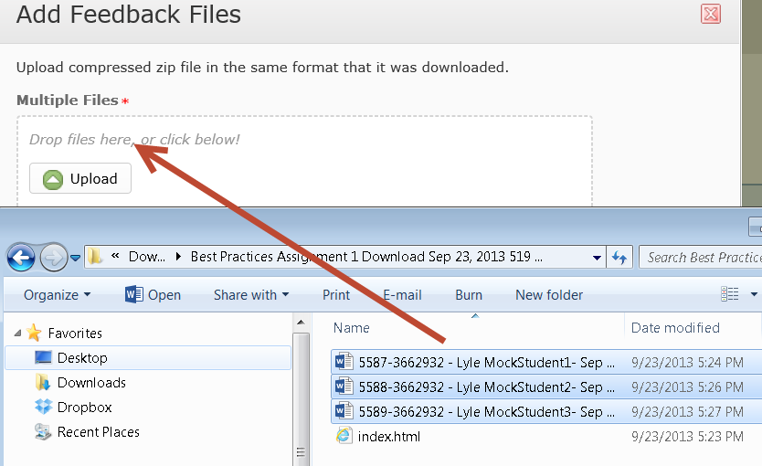
Alternatively, you can upload a zip file. To upload the zip file, select the files on your PC, right-click, and Send to Compressed (zipped) folder. It is okay to include or exclude the index.htm file. A new folder is created. A name will be assigned. There is no need to change the name, it contains all of the student folders and should upload and import correctly.
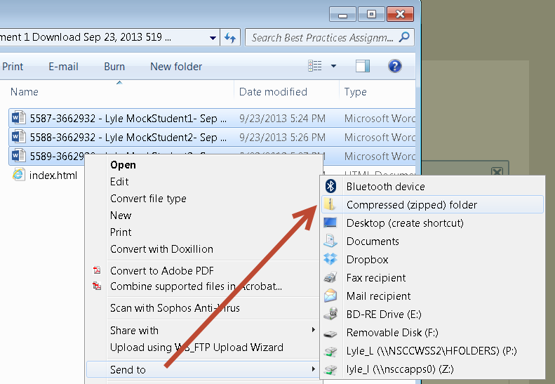
The zip file can be identified by the zip folder icon to the left of the file name.

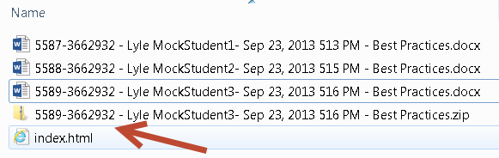

In D2L, click on the Add Feedback Files button on the Folder Submissions screen. Locate the zip file. Click the Upload button.
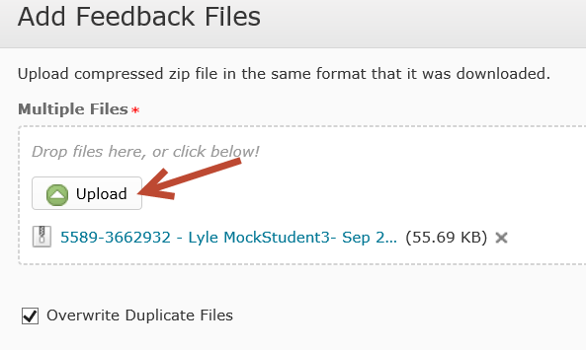
Look for the message that the file(s) attached successfully.
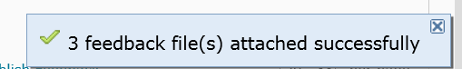
After the files upload, each student’s submission should report “Draft Saved.” This indicates that the files have been uploaded to return to the students. It make take a few minutes for the files to be uploaded. Be patient.
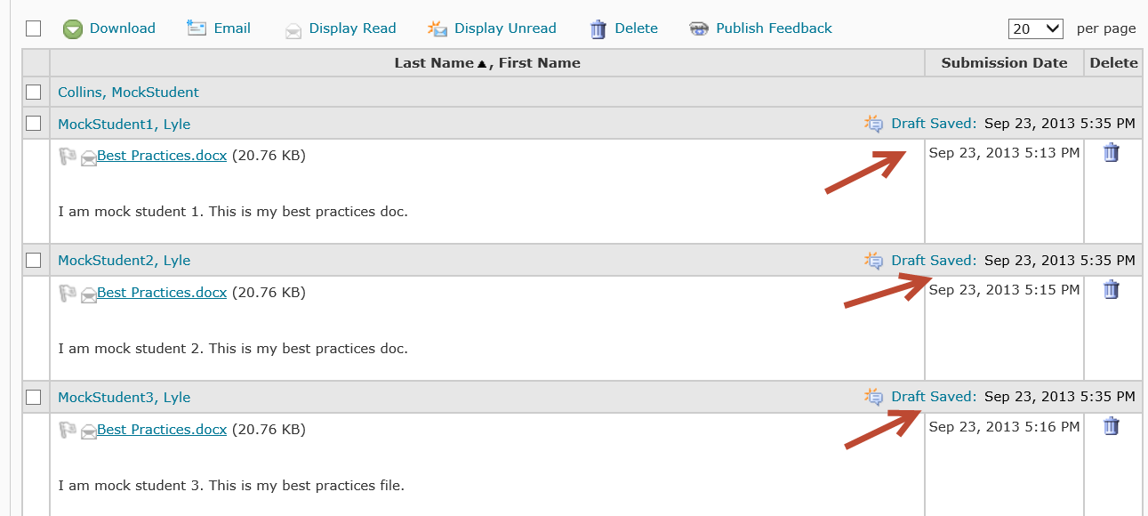

To assign a numerical score, click on Draft Saved for each student and enter a score. At this point you can publish each score individually.
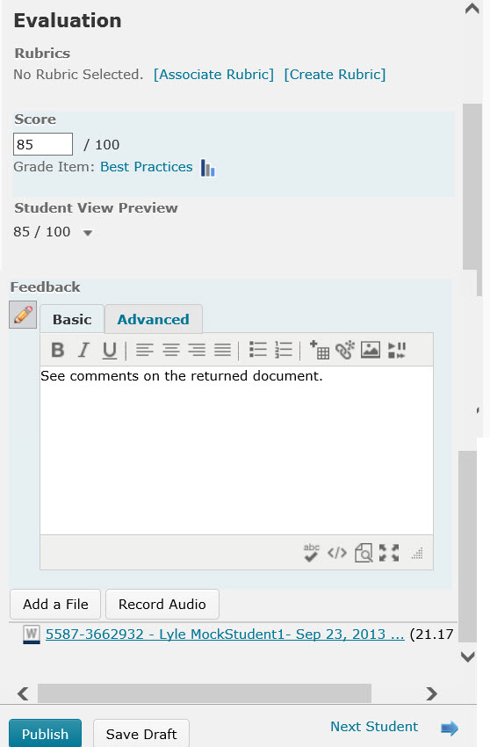

If you prefer to return all papers at the same time, save each one individually as a draft after you enter the score. To make the graded assignments available to the students, click on Publish Feedback after all grading has been completed.

